**Lexar® JumpDrive® Dual Drive D400 USB 3.2 Gen 1 Type-C™**

512GB

256GB

128GB

32GB

[Where to buy](https://americas.lexar.com/product/lexar-jumpdrive-dual-drive-d400-usb-3-2-type-c/)

**Key Features:**

**Up to 130MB/s read**

* Dual USB Type-CTM/A Connectors
* With Key Ring Loop
* Compatible with Android, PC and Mac system
* 256-bit AES Encryption

**Key Features:**

**Up to 130MB/s read**

* Dual USB Type-CTM/A Connectors
* With Key Ring Loop
* Compatible with Android, PC and Mac system
* 256-bit AES Encryption

**Key Features:**

**Up to 130MB/s read**

* Dual USB Type-CTM/A Connectors
* With Key Ring Loop
* Compatible with Android, PC and Mac system
* 256-bit AES Encryption

**Key Features:**

**Up to 130MB/s read**

* Dual USB Type-CTM/A Connectors
* With Key Ring Loop
* Compatible with Android, PC and Mac system
* 256-bit AES Encryption

**Key Features:**

**Up to 130MB/s read**

* Dual USB Type-CTM/A Connectors
* With Key Ring Loop
* Compatible with Android, PC and Mac system
* 256-bit AES Encryption

[Features](https://americas.lexar.com/product/lexar-jumpdrive-dual-drive-d400-usb-3-2-type-c/#feature-section)[Specifications](https://americas.lexar.com/product/lexar-jumpdrive-dual-drive-d400-usb-3-2-type-c/#specifications)[Part Numbers](https://americas.lexar.com/product/lexar-jumpdrive-dual-drive-d400-usb-3-2-type-c/#product-numbers)[Related products](https://americas.lexar.com/product/lexar-jumpdrive-dual-drive-d400-usb-3-2-type-c/#related-products)

**Features**

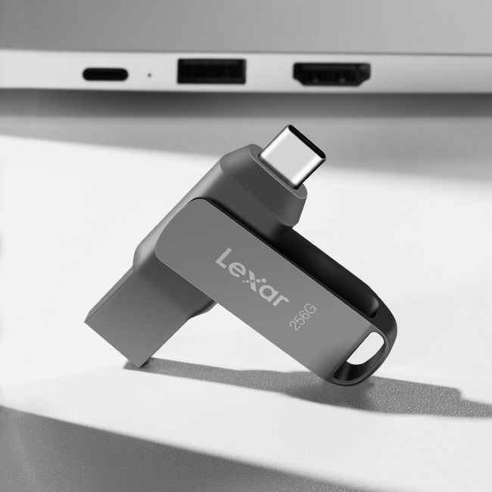

**2-in-1 flash drive for your USB Type-C™ and Type-A devices**

The Lexar® JumpDrive® Dual Drive D400 USB 3.2 Gen 1 Type-CTM is a 2-in-1 flash drive that allows you to seamlessly transfer content between your USB Type-CTM and Type-A devices. Featuring a stylish metal casing and swivel design for added protection, this drive is as tough as it is fast with transfer speeds up to 130MB/s1.

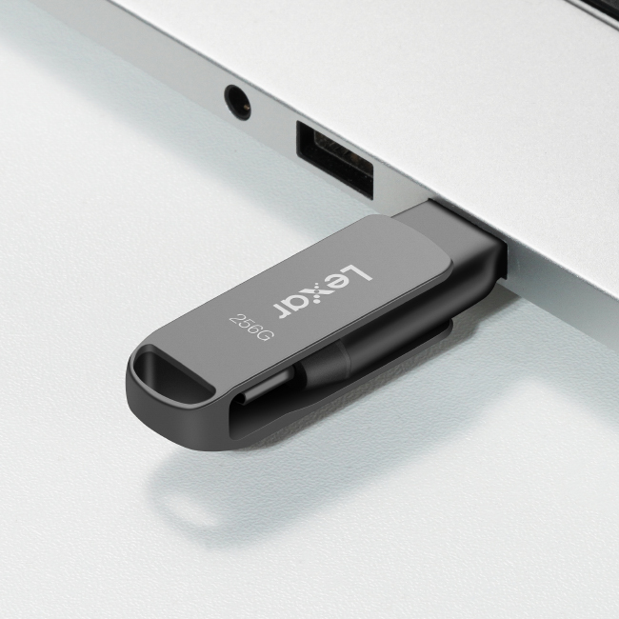

**Quickly transfer your favorite content**

Featuring high-speed USB 3.2 Gen 1 performance and transfer speeds up to 130MB/s¹ read, this drive lets you quickly and easily move your files to your smartphone, tablets, and computers.

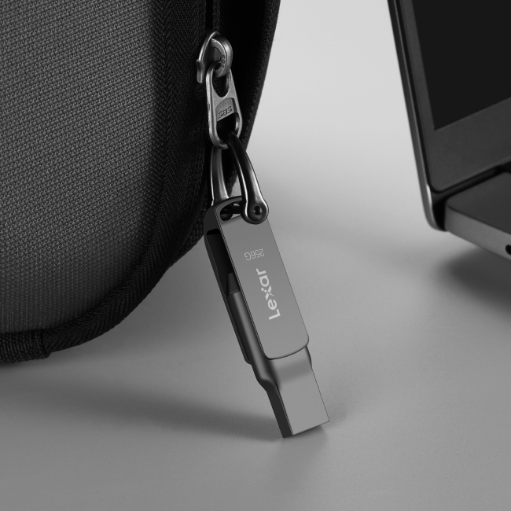

**Stylish metal housing and swivel design**

The stylish metal housing design with the key ring loop provides outstanding durability while protecting the connectors while on the go.

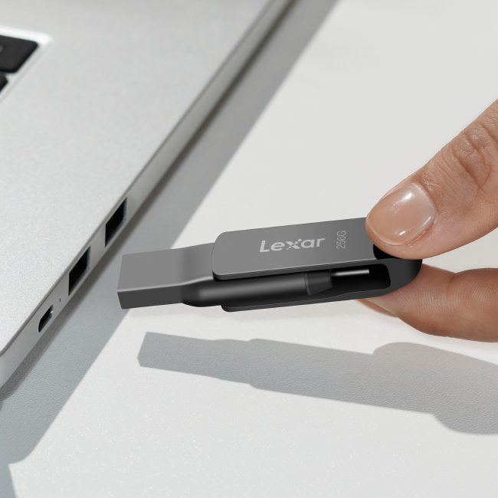

**Secure your files with Lexar Data Shield**

Easily create a password-protected safe that automatically encrypts data. And for peace of mind, files deleted from the safe are securely erased and can’t be recovered.

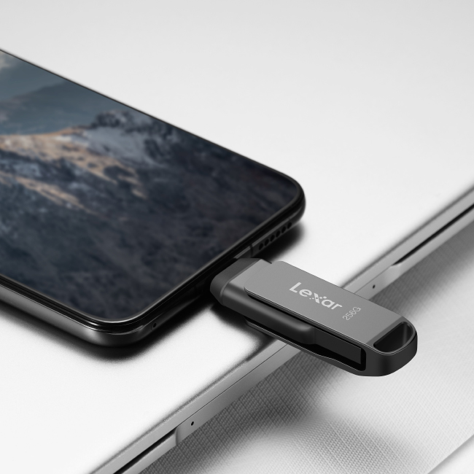

**Compatible with AndroidTM, PC, and Mac® systems**

Compatible with USB Type-C and Type-A connectors, the Lexar® JumpDrive® Dual Drive D400 USB 3.2 Type-C™ allows you to easily transfer your files between your USB Type-C smartphones, tablets, laptops, Macs, and traditional Type-A devices.



**Rigorously Tested**

All Lexar products undergo extensive testing in the Lexar Quality Labs, facilities with thousands of different cameras and digital devices to ensure performance, quality, compatibility, and reliability.

**Specifications**

* Capacity

512GB | 256GB | 128GB | 32GB

* Interface

USB 3.2 Gen 1

* Performance

64GB – up to 130MB/s¹  
128GB – up to 130MB/s¹  
256GB – up to 130MB/s¹  
512GB - up to 170MB/s¹

* Operating Temperature

0°~50°C (32°F to 122°F)

* Storage Temperature

-10°C~70°C (-1°F to 158°F)

* Dimension (LxWxH)

60.6mm x 16.2mm x 9.7mm / 2.386” x 0.638” x 0.382”

* Weight

17.8 g / 0.0392 lbs

* Warranty

5-year limited warranty